# Introduction

This GDD describes the features of a game to be implemented in the project ARGO game “Pirates Playground”.

# Player experience goals

## Core Aesthetics:

* Tense
* Frantic
* Excited
* Panic
* Heroic

## Player Feeling:

During the game, the player should feel like they’re in a panic to get the tasks done in time. This will then lead to the player becoming excited and heroic if they manage to complete the tasks in time.

# 

# 

# Features

## [**Display level**](http://jira.itcarlow.ie:8080/browse/GJPTEAMC-1)

User can see initial level.

### **Conditions of satisfaction**

* The game will be shown filling a 1920x1080 window.
* The boat race will be displayed in the centre of the screen.
* The view of the playground will be displayed in a ¾ top down perspective.
* The boat race will be displayed in a top down perspective.

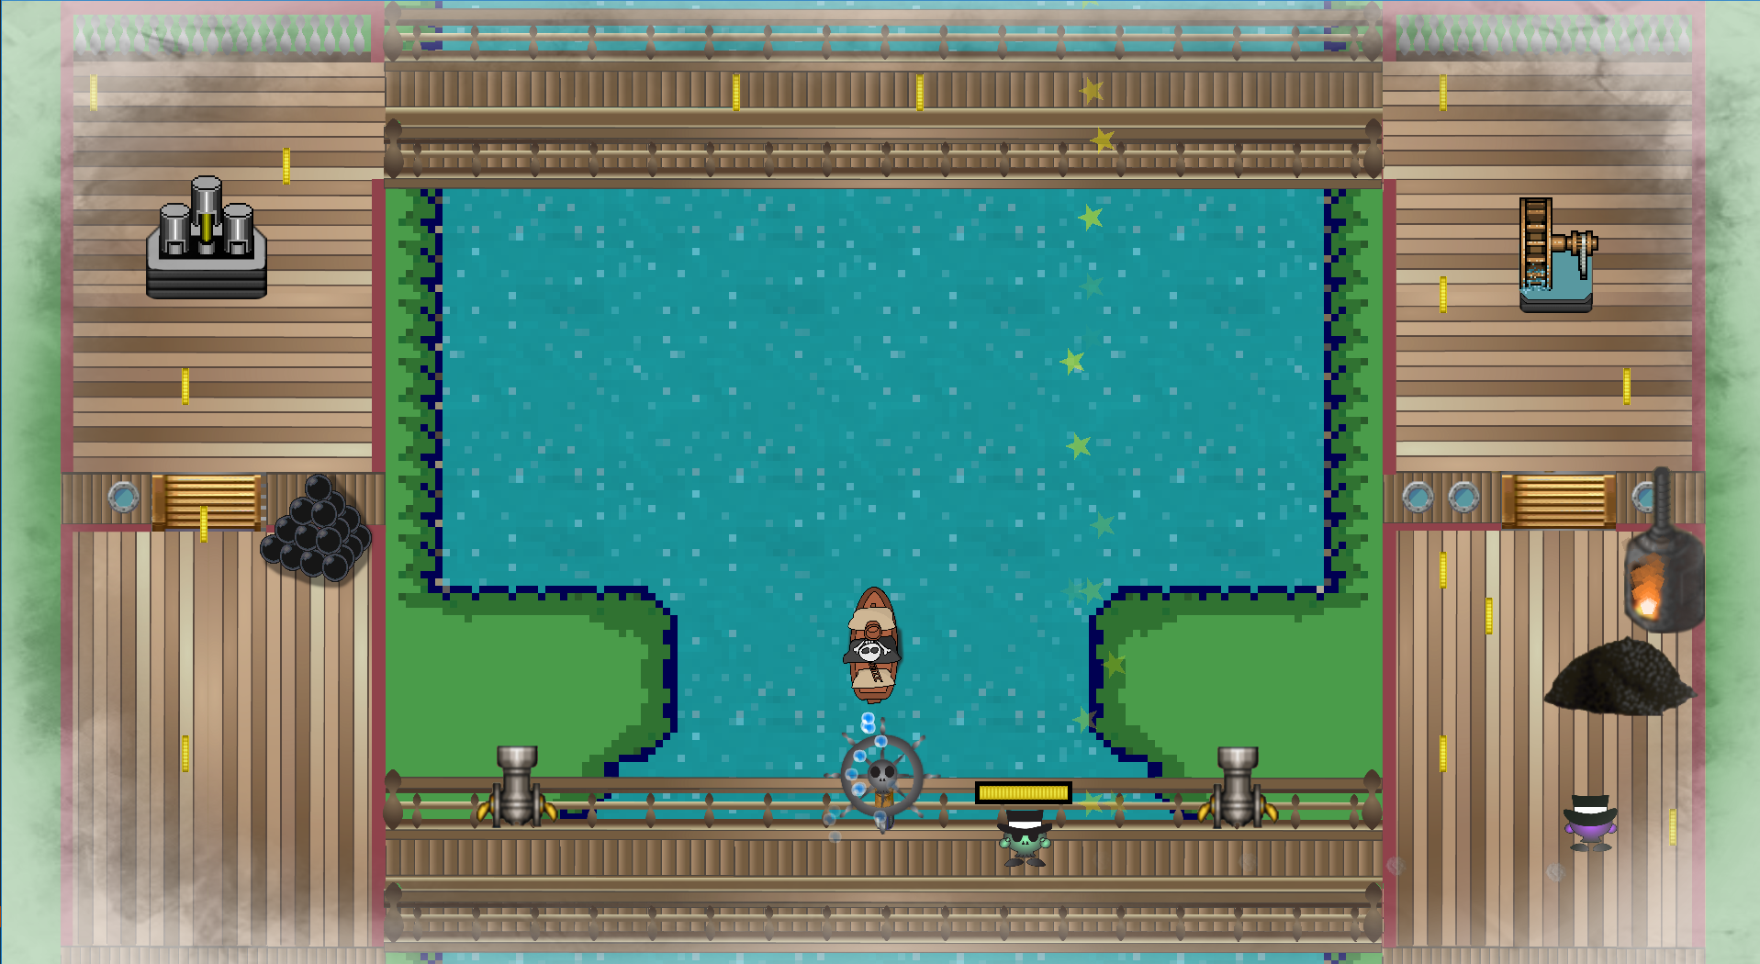

### **Manual Test -** [**VIDEO**](https://drive.google.com/file/d/0B6fz6Y9CduvYNzR2d1lJVlozUlU/view?usp=sharing)

* Ran application and level was displayed.
* Boat race was displayed in a top down perspective in the centre of the screen.
* The view of the playground boat was displayed in a ¾ top down perspective along the outside of the screen.

### 

## [**Player Control**](http://jira.itcarlow.ie:8080/browse/GJPTEAMC-4)

User can move player character using the left analogue stick on the controller.

### **Conditions of satisfaction**

* The player's movement speed is based on the distance of the analogue stick from the centre.
* The player’s direction is based on the direction in which the analogue stick is pointed.
* The player will be prompted to press the “A” button to interact with the station.
* When the player begins the interaction with the station, they will be prompted with an instruction on how to complete the task. (eg. Tap X Button)
* The player’s action is illustrated on the ship in the centre of the screen.

### **Manual Test -** [**VIDEO**](https://drive.google.com/file/d/0B6fz6Y9CduvYdEpkakZ4SzJhbGc/view?usp=sharing)

* Player moved faster the further away the stick was pushed from the centre.
* Player moved in the direction the stick pointed.
* Notification appeared saying to press A to activate station.
* Each station prompted a different action when activated.
* The action had an effect on the boat.

## [**Ship**](http://jira.itcarlow.ie:8080/browse/GJPTEAMC-10)

The ship will be displayed in the centre of the screen.

### **Conditions of satisfaction**

* The ship can be turned by a player controlling the steering wheel inside the ship.
* The ship speed is controlled by the furnace station inside the ship.
* If the ship collides with a rock, it will stop/slow down.
* The ship can take damage if it were to crash, this could cause the “rudder” or the “engine” to break.
* The ship can be repaired by completing the tasks at a specific station.
* If the ship's rudder is broken the ship will not be able to steer.
* If the ship’s engine is broken the boat will slow down to a sailing pace.

### **Manual Test -** [**VIDEO**](https://drive.google.com/file/d/0B6fz6Y9CduvYellkbmwtXy05QjA/view?usp=sharing)

* The direction the ship was moving was determined by the steering wheel station on the playground.
* Ship moved faster when the furnace was used.
* Ship stopped on collision with a wall.
* Engine and/or rudder would break if crashed too many times.
* Rudder and engine could be repaired on the playground.
* Ship would move slowly if engine was damaged and would not steer if rudder was broken.

## [**Collision**](http://jira.itcarlow.ie:8080/browse/GJPTEAMC-18)

Collision detection and response between entities.

### **Conditions of satisfaction**

* Player can collide with the walls within the playground ship.
* Player can collide with the different entities within the playground (eg. Stations).
* The ship in the race can collide with the land or logs scattered throughout the level.
* The ship can also collide with the octopus on the river which will cause the octopus to explode and each player will have their number of coins reduced.
* Collision with objects within the race can result in the boat being damaged.

### **Manual Test -** [**VIDEO**](https://drive.google.com/file/d/0B6fz6Y9CduvYQXVzRkJRQ1huNms/view?usp=sharing)

* Could not walk through walls on the playground.
* Could not walk through the stations.
* Ship could not sail through the obstacles on the river.
* Colliding with an octopus would make it explode and coins were reduced.
* Boat was damaged from crashing.

## [**Tiles**](http://jira.itcarlow.ie:8080/browse/GJPTEAMC-13)

The playground boat level is made up of tiles.

### **Conditions of satisfaction**

* Each tile will be 64x64 pixels in size.
* The width of the playground boat will consist of 29 tiles.
* The height of the playground boat will consist of 17 tiles.



### **Manual Test -** [**VIDEO**](https://drive.google.com/file/d/0B6fz6Y9CduvYNzR2d1lJVlozUlU/view?usp=sharing)

* Tiles were loaded in upon entering the game Scene and multiplayer game scene.

## [**Steering Wheel Station**](http://jira.itcarlow.ie:8080/browse/GJPTEAMC-21)

Steering wheel on the playground that controls the boat in the race.

### **Conditions of satisfaction**

* Steering wheel is placed on the playground ship.
* Once in position to activate the steering wheel, the player is presented with a notification telling them what button to press.
* Player can activate the steering wheel station by pressing the “A” button whilst in front of it.
* When the station is active, the player can rotate the left analogue stick to turn the ship.
* Rotating the stick clockwise will turn the ship right.
* Rotating the stick anti-clockwise will turn the ship left.
* The player can leave the station by pressing the “A” button whilst the station is active.

### **Manual Test -** [**VIDEO**](https://drive.google.com/file/d/0B6fz6Y9CduvYNWR4SDBKOTlhV1k/view?usp=sharing)

* Steering wheel was placed on the center bottom region of the screen.
* Notification appeared when nearby the wheel
* Pressing A gave control of the wheel
* ship turned right after rotating the wheel clockwise.
* ship turned left after rotating the wheel anticlockwise

### 

## [**Cannon Station**](http://jira.itcarlow.ie:8080/browse/GJPTEAMC-20)

Cannon on the ship to fire at entities within the game world.

### **Conditions of satisfaction**

* Cannon is placed on the playground ship.
* Cannon must be loaded with a cannon ball to be able to fire.
* Player can pick up a cannon ball by walking over to the stack of cannonballs and pressing “A”.
* If player is holding a cannon ball and is in range of the cannon, they can press “A” to load the cannon ball.
* If the player presses “A” on a loaded cannon, it will fire straight ahead.

### **Manual Test -** [**VIDEO**](https://drive.google.com/file/d/0B6fz6Y9CduvYTldfRkJKM3VPWU0/view?usp=sharing)

* Cannons appeared on the bottom of the screen.
* Cannon fired a cannon ball after pressing “A” when the cannon was loaded.
* Pressing “A” when the cannon was in range and it was not loaded , resulted in loading the cannon.
* Cannon ball fired straight ahead of the ship.

## [**Furnace Station**](http://jira.itcarlow.ie:8080/browse/GJPTEAMC-35)

Furnace on the ship that controls the speed of the ship.

### **Conditions of satisfaction**

* Furnace is placed on the playground ship.
* Furnace sation is activated when a player walks up to it and presses the A button.
* To operate the station the player must alternate pressing the X and B buttons.
* The faster the player operates the station the quicker the ship will accelerate.
* The player can leave the station by pressing A.

### **Manual Test -** [**VIDEO**](https://drive.google.com/file/d/0B6fz6Y9CduvYTlpfUzJFb2Q5WW8/view?usp=sharing)

* Furnace appeared on the ship.
* Furnace activated after pressing “A” when in range.
* “Pressing “X” and “B” increased the speed of the ship.

## [**Engine Station**](http://jira.itcarlow.ie:8080/browse/GJPTEAMC-39)

Engine on the ship that can be damaged from crashing.

### **Conditions of satisfaction**

* The engine can only take a certain amount of damage before breaking.
* If the engine is damaged the boat will move at a sailing speed.
* If the engine is functioning perfectly it will be able to reach its max speed.
* The engine station can be activated by pressing A on it when it is damaged.
* Upon activating the engine station the player will be told to press a sequence of buttons to repair the engine.
* If the player completes the button sequence successfully the engine will be restored to be functioning.
* If the player presses the wrong button during the sequence they will be kicked off the station.
* If the engine is damaged, it will be illustrated via particles with a fire effect.

### **Manual Test -** [**VIDEO**](https://drive.google.com/file/d/0B6fz6Y9CduvYbkczSjdfaUhicGs/view?usp=sharing)

* Engine station was activated after pressing “A” when within range.
* After pressing the correct buttons a number of times , the ship's max speed was restored.

## [**Rudder Station**](http://jira.itcarlow.ie:8080/browse/GJPTEAMC-70)

Rudder on the ship that can be damaged from crashing.

### **Conditions of satisfaction**

* The rudder can only take a certain amount of damage before breaking.
* If the rudder is damaged the steering wheel will no longer work.
* If the rudder is functioning perfectly the steering wheel will control the direction the boat is moving.
* The rudder station can be activated by pressing A on it when it is damaged.
* Upon activating the engine station the player will be told to rapidly tap the X button to repair it..
* If the player completes the button sequence successfully the rudder will be restored to be functioning.
* The faster the player taps the x button, the faster the rudder will be repaired.
* If the rudder is damaged, it will be illustrated via particles with a fire effect.

### **Manual Test -** [**VIDEO**](https://drive.google.com/file/d/0B6fz6Y9CduvYTldfRkJKM3VPWU0/view?usp=sharing)

* When the rudder took damage particle effects appeared.
* When damaged and within range pressing “A” activated the station.
* After repeatedly pressing X , the particle effects disappeared and the ships wheel functionality was restored.

## [**Game World**](http://jira.itcarlow.ie:8080/browse/GJPTEAMC-33)

The game world will be displayed from a top down perspective in the centre of the screen..

### **Conditions of satisfaction**

* The boat will start the race in the centre of the screen.
* As the boat moves forward the camera will scroll to keep the player on screen.
* The game world is made up of 64x64 tiles.
* The world is 17 tiles in width and 500 tiles in length.

### **Manual Test -** [**VIDEO**](https://drive.google.com/file/d/0B6fz6Y9CduvYTldfRkJKM3VPWU0/view?usp=sharing)

* After running the game , the camera was centred around the boat’s position.

## 

## [**Networking**](http://jira.itcarlow.ie:8080/browse/GJPTEAMC-36)

Playing a single game against other players on different networks.

### **Conditions of satisfaction**

* Clients can connect to a server.
* Clients can select a room they wish to join.
* Clients in the lobby are notified when someone joins or leaves a room
* Game starts when the room has reached its maximum capacity of clients.
* Allow for 4 players to play simultaneously.
* Interpolate remote players pos,vel and rotation.
* Extrapolate remote players when no packet data is available.
* Query server for results on the race.

### **Manual Test -** [**VIDEO**](https://drive.google.com/file/d/0B6fz6Y9CduvYZ3RlUkhMZUtLTVE/view?usp=sharing)

* Pressing A on the connect button in the multiplayer scene connects player to the server
* Pressing A on the highlighted room adds player to the room if the room is not full or a game is not currently active in that room.
* Pressing A in the pre game lobby removes the player from the room and updates the room size for other players waiting in the lobby.
* Moving the analog switches the room which the player will be added to.
* Highlighting the main menu button and pressing A will disconnect the player from the server.
* When the maximum amount of players has joined a room the game will start.

## [**In Game Currency**](http://jira.itcarlow.ie:8080/browse/GJPTEAMC-86)

Game has in game currency used to use certain stations

### **Conditions of satisfaction**

* Player earns coin upon collision
* Coins spawn in game
* Player spends money when using specific station

### **Manual Test -** [**VIDEO**](https://drive.google.com/file/d/0B6fz6Y9CduvYcXhRclR0UXZMUEE/view?usp=sharing)

* After colliding with a coin . The coin tally for the player increased.
* When activating either the cannon ball , wheel or furnace station . The coin tally for the player decreased.

## 

## [**Audio**](http://jira.itcarlow.ie:8080/browse/GJPTEAMC-69)

Game plays audio based on specific events

### **Conditions of satisfaction**

* Background music plays in game
* sfx plays when purchasing a station
* Sfx plays when loading a cannon
* Sfx plays when firing a cannon
* Sfx plays sfx plays when fixing the rudder and engine station
* Error sfx plays when fixing the rudder and engine station and a wrong button is pressed
* Sfx plays upon collision with octopus
* Sfx plays upon collision between octopus and cannon ball
* Player spends money when using specific station

### **Manual Test -** [**VIDEO**](https://drive.google.com/file/d/0B6fz6Y9CduvYTldfRkJKM3VPWU0/view?usp=sharing)

* After loading the game scene , background music played.
* When purchasing a station , loading a cannon , fixing either the rudder or engine station or colliding with an octopus sfx was played.
* After shooting an octopus with a cannon ball or crashing into one with the boat an sfx was played.
* After purchasing a station an sfx was played.
* During the process of fixing either the rudder or engine station an sfx was played . If the wrong sequence was entered a error sfx was played.

## 

## 

## [**Artificial Intelligence**](http://jira.itcarlow.ie:8080/browse/GJPTEAMC-81)

Character in game who is controlled by AI.

### **Conditions of satisfaction**

* AI characters aim is to complete the race.
* AI takes into account all the jobs that need to be done (eg. Steer the wheel/ Fix the engine).
* Each potential job has a score based on importance.
* The job with the highest score of importance will be attempted by the AI player.
* The AI will steer the ship towards the waypoints set out on the map.
* The AI will shovel coal if the ship is moving slowly.
* The AI will fix the engine if it is damaged.
* The AI will repair the rudder if it is broken.
* If the job that the AI wants to do is being attempted by another player, he will move on to the task with the second highest priority.

### **Manual Test -** [**VIDEO**](https://drive.google.com/file/d/0B6fz6Y9CduvYZ3RlUkhMZUtLTVE/view)

* When activating the wheel, the ai would steer to avoid the obstacles.
* When the ship was moving slowly, the ai would move to the furnace and shovel coal.
* If the engine was damaged the AI would move to the engine to repair it.
* If the rudder was broken the AI would move to the rudder to repair it.
* The AI would not go to the same station as another player is currently using.

## [**Multiple Players**](http://jira.itcarlow.ie:8080/browse/GJPTEAMC-38)

More than one player on the screen. AI player or another human player.

### **Conditions of satisfaction**

* If there are two controllers plugged in the characters on the playground will be controlled by them.
* If only one controller was plugged in, the second character will be controlled by the AI.
* If there are no controllers plugged in, both characters will be controlled by AI.

### **Manual Test**

* Ran the game with two controllers and each controller controlled a player.
* Ran the game with one controller and it controlled one player whilst the other player was controlled by AI.
* Ran the game without a controller and both players were controlled by AI.

## 

## 

## [**Menu System**](http://jira.itcarlow.ie:8080/browse/GJPTEAMC-37)

Menu system to navigate through scenes.

### **Conditions of satisfaction**

* Specific background image based on the current scene.
* Play and Quit buttons on title screen.
* Play button will open a subset of buttons for a Local or an Online game.
* Selecting the quit button will close the application.
* Selecting the local button will start a local game.
* Selecting the online button will open a connect scene.
* The connect scene will have a button for Connect and a button to return to the main menu.
* Selecting the connect button will bring the user to a room scene where they can chose between 3 rooms to join or return to the main menu.
* When the user selects a room to join they will be brought to the pre game lobby, where they can wait for more players to join a game.
* Once the required number of players join the game, they game will be loaded up and will begin after a 5 second countdown.

### **Manual Test -** [**VIDEO**](https://drive.google.com/file/d/0B6fz6Y9CduvYREJxWC1FY1hrNEE/view?usp=sharing)

* Pressing buttons in each menu would bring you to a different scene depending on the button.